Abstract Guidelines
XII International Scientific Conference
“Microbial biotechnologies: fundamental and applied aspects”,
Minsk, 7-11 June 2021

Abstracts in Russian or English languages are submitted via on-line system available at official website of the Institute of Microbiology, Belarus Academy of Sciences (http://mbio.bas-net.by/2021/submission_en.php).
File size up to 2 Мb.
Abstract volume up to 2 pages processed in any text editor program with extensions .doc, .docx, .odt or .rtf.
Paper sheet size А4 (297×210 mm), book orientation, margins 20 mm, indentation 10 mm, alignment in width.
Font Times New Roman, 14 pt, line spacing 18 pt. Automatic word hyphenation at line ends is essential. The pages are not numbered.
Abstract title – Times New Roman font, 17 pt, bold typeface, alignment to the left. Surnames and initials of the authors – Times New Roman font, 14 pt, bold typeface, alignment to the left. Name of the Institution – Times New Roman font, 13 pt, italic typeface, alignment to the left.
Tables are generated via Table option and their content is formed using font Times New Roman 12 pt, at ordinary spacing. Table heading specifications – Times New Roman 14 pt font, ordinary spacing, alignment to the left.
Figures must be of acceptable for view size and quality. Composite figures should be grouped. Capture of the figure should be typed in Times New Roman 14 pt, bold typeface, at ordinary spacing, aligned to the center. Legend to the figure, typed in Times New Roman, 12 pt, ordinary spacing, is placed between figure and capture.
References numbered sequentially in the order of their citation in the text are inserted between square brackets. The list of references finalizing the abstract is performed in Times New Roman 12 pt at ordinary spacing, alignment to the left (citation style according to Rules of Supreme Attestation Comission of the Republic of Belarus – http://www.vak.org.by/index.php/bibliographicDescription).
The symbols (β, ×, ±) should be introduced into the text via the option Insert → Symbol. Latin designations are italicized (e.g. Aspergillus niger BIM F-65).

The authors of accepted abstracts carry responsibility for authenticity of presented results, compliance with authorship rights, accuracy of citations, legalization of data not subject to public disclosure.
The Organizing Committee reserves the right to reject abstracts not meeting the established deadline, thematic profile or format criteria and to modify the text in a way not affecting its scientific content.
The authors will receive e-mail confirmation of abstract receipt by Organizing Committee. In case such confirmation is delayed please contact Organizing Committee by e-mail: conference@mbio.bas-net.by.

Abstract template

Molecular-genetic analysis of determinants, coding for synthesis of antimicrobial metabolites in bacteria of genus Bacillus
Berezhny A.¹, Petrov P.^{1,2}, Ivanov V.²
¹Institute of Microbiology NAS Belarus, Minsk, Belarus,
e-mail: name@mail.ru
²Faculty of Chemistry, M.V. Lomonosov Moscow State University, Moscow, Russia

Bacteria of genus Bacillus are producers of a wide spectrum of biologically active substances, including antibiotics, surface-active agents, enzymes, etc., which determine their application for development of biopreparations for plant protection [1]. The most well-known antagonistically active metabolites of bacilli are lipopeptides of surfactin (fig. 1) and iturin groups [2, 3].

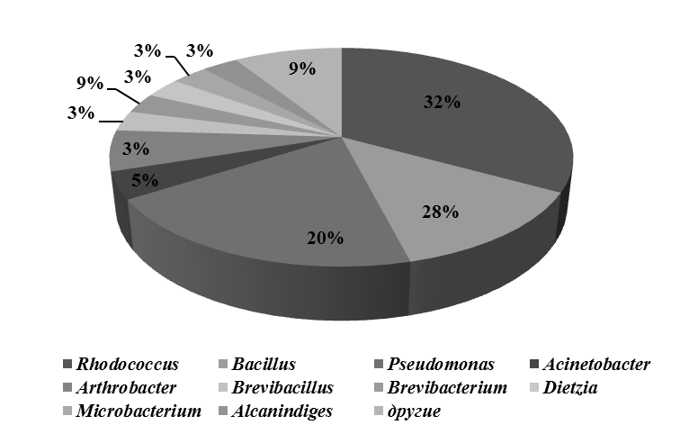
Figure 1 – Taxonomic affiliation of studied test-cultures of microorganisms

One of the prospective directions of bioremediation of environment is introduction of active microorganisms-destructors of xenobiotics in soil, contaminated with pesticides (Tab. 2).

Table 2 – Growth of bacteria at different oil concentrations
Oil concentration,  % | Strain
Oil concentration,  % | 90 | 102 | 108 | 109 | 112 | 114
5 | 25 | 22 | 30 | 24 | 35 | 32
10 | 15 | 13 | 11 | 12 | 28 | 23
15 | 12 | 10 | 10 | 10 | 24 | 22
20 | 9 | 7 | 7 | 8 | 16 | 18
50 | 5 | 4 | 5 | 6 | 8 | 10

Literature
1. Harpin induces disease resistance in Arabidopsis through the systemic acquired resistance pathway mediated by salicylic acid and the NIM1 gene / H. Dong [et al.] // Plant J. – 1999. – Vol. 20, № 2. – P. 207-215.
3. Fontanilla, M. Effects of the foliar-applied protein “Harpin(Ea)” (messenger) on tomatoes infected with Phytophthora infestans / M. Fontanilla, M. Montes, R. De Prado // Communications in agricultural and applied biological sciences. – 2005. – Vol. 70, № 3. – P. 41-45.

